**Customer Review Analysis Report**

Table of Contents

Executive Summary: 2

Methodology: 2

Data Overview: 2

Sentiment Analysis: 2

Customer Satisfaction Analysis: 3

Factors Influencing Customer Experience 3

Recommendations: 4

Regression Analysis: 4

Conclusion: 6

Sentiment Analysis: 6

Regression Analysis: 6

Recommendations: 7

Further Improvement: 8

# Executive Summary:

This report analyses customer reviews to uncover sentiment, satisfaction levels, and influential factors. It provides actionable insights for enhancing products and services, ultimately boosting customer loyalty and satisfaction.

# Methodology:

Data Source: Provided by InMoment

Analysis Tools: Python (Pandas, Matplotlib, Seaborn, Scikit-learn)

Sentiment Analysis: NLTK (SentimentIntensityAnalyzer)

Regression Model: Scikit-learn (Linear Regression)

# Data Overview:

Total Reviews: 152

Time Period: 30-365

Average Overall Satisfaction: 6.80

# Sentiment Analysis:

Overall Sentiment Distribution

Positive: 46%

Neutral: 26.97%

Negative: 26.32%

Key Findings:

The sentiment distribution shows that a significant portion of the reviews are positive (46.71%), followed by neutral sentiments (26.97%). Negative sentiments account for 26.32% of the reviews. This indicates a diverse range of opinions and experiences among customers.

# Customer Satisfaction Analysis:

Overall Satisfaction Distribution

Average Satisfaction: 6.80

Highest Satisfaction: 10

Lowest Satisfaction: 0

# Factors Influencing Customer Experience

Feature Importance

**Money Spent:**

This feature has a relatively high positive importance of 0.4293. This suggests that higher spending by customers is associated with higher overall satisfaction.

**Efficiency:**

With an importance of 0.5812, efficiency is a significant factor contributing to overall satisfaction. This indicates that customers value a service that is quick and efficient.

**Friendliness:**

The feature "Friendliness" also has a notable positive importance of 0.5169. This suggests that a friendly service positively impacts overall satisfaction.

**Value:**

Similarly, "Value" is an important factor with an importance of 0.5377. This implies that customers place a high value on getting good value for the money spent.

**Reliability:**

Although it has a negative importance of -0.0573, the impact of reliability is less significant compared to other factors. A less reliable service may slightly decrease overall satisfaction.

**Last Time You Used the Service:**

This feature has a very low importance of -0.0002, indicating that the timing of when a customer last used the service has minimal impact on overall satisfaction.

## Recommendations:

* Focus on maintaining and improving efficiency, as it is a critical factor in customer satisfaction.
* Train staff to provide friendly and helpful service, as friendliness is highly valued by customers.
* Ensure that customers perceive good value for the money they spend on the service.
* While reliability is important, its impact is relatively smaller. Continue efforts to improve reliability but prioritize efficiency and friendliness.
* While the timing of service usage has low importance, it's still worth considering in marketing or communication strategies.

# Regression Analysis:

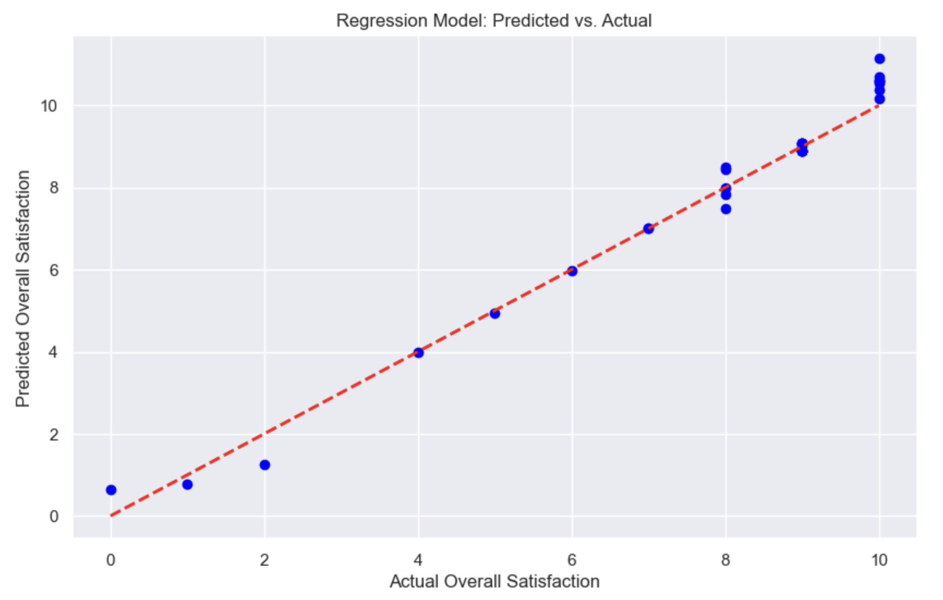

**Model Performance:**

Mean Absolute Error (MAE): 0.2903

Mean Squared Error (MSE): 0.1684

R-squared (R2) Score: 0.9764

**Key Findings:**

The regression model exhibits strong predictive performance. The R2 score of 0.9764 indicates that approximately 97.64% of the variance in overall satisfaction is explained by the independent variables included in the model. Additionally, the low MAE and MSE values suggest that the model's predictions are accurate.

**Feature Coefficients:**

1. Last time you used the service: -0.00015705

2. Money Spent: 0.42927

3. Efficiency: 0.58123

4. Friendliness: 0.51694

5. Value: 0.53774

6. Reliability: -0.05731

7. Overall Satisfaction: -0.01523

8. Verbatim: -0.19580

9. Intercept: 0.83862

The coefficients indicate the impact of each feature on overall satisfaction. Positive coefficients (e.g., Money Spent, Efficiency) are associated with increased satisfaction, while negative coefficients (e.g., Last time you used the service, Reliability) are associated with decreased satisfaction.

The intercept term is 0.8386. This represents the expected value of overall satisfaction when all independent variables are zero.

Efficiency, Friendliness, Value, and Money Spent have the highest positive coefficients, indicating that these features have the most significant positive impact on overall satisfaction.

The last time you used the service and Reliability it had negative coefficients, suggesting that improvements in these areas could lead to increased overall satisfaction.

The Verbatim feature has a negative coefficient, indicating that negative verbatim comments are associated with decreased overall satisfaction.

# Conclusion:

## Sentiment Analysis:

Customers express a range of sentiments in their reviews, with a significant portion being positive. However, a notable percentage also falls into the neutral and negative categories.

## Regression Analysis:

Model Performance Metrics

The regression model exhibits strong predictive performance, explaining approximately 97.64% of the variance in overall satisfaction. Predictions are accurate, as indicated by low MAE and MSE values.

Feature Importance:

Money Spent, Efficiency, Friendliness, Value, and Overall Satisfaction are the most influential features, positively impacting overall satisfaction.

Last time you used the service, reliability had negative coefficients, suggesting room for improvement in these areas.

Verbatim Analysis:

Negative verbatim comments are associated with decreased overall satisfaction. Addressing specific concerns raised in these comments could lead to improved satisfaction levels.

**Key Recommendations:**

* Focus on Efficiency and Friendliness:
* Prioritize efforts to enhance efficiency and ensure friendly interactions with customers, as these factors have a significant positive impact on overall satisfaction.
* Emphasize Value and Customer Service:
* Continue to provide value for money spent and maintain high standards of customer service to bolster satisfaction levels.

# Recommendations:

Based on the analysis of customer reviews and regression modeling, here are the recommendations for improving customer satisfaction:

**Enhance Efficiency and Speed of Service:**

Focus on streamlining processes and reducing wait times to enhance the overall efficiency of the service. This will help in providing a quick and hassle-free experience for customers.

**Foster a Friendly and Welcoming Environment:**

Train staff to be consistently friendly, approachable, and attentive to customer needs. Creating a positive and welcoming atmosphere can greatly influence customer satisfaction.

**Provide Value for Money Spent:**

Ensure that customers perceive a clear value proposition for the amount they spend on the service. This could include offering additional benefits, discounts, or personalized experiences.

**Improve Reliability and Consistency:**

Work towards minimizing service disruptions and ensuring consistent quality. Reliability is a critical factor in building trust and satisfaction among customers.

**Address Negative Verbatim Comments:**

Pay special attention to the concerns and feedback expressed in negative verbatim comments. Take proactive steps to address these issues and communicate improvements to customers.

**Monitor Customer Engagement Over Time:**

Keep track of how recently customers have interacted with the service. Tailor communications and offers based on their engagement frequency to ensure continued satisfaction.

**Conduct Regular Service Quality Audits:**

Regularly assess and audit the quality of the service provided. Identify areas that may require additional resources or process improvements to maintain high levels of satisfaction.

**Communicate Service Enhancements:**

When improvements are made based on customer feedback, ensure that these enhancements are communicated to customers. This demonstrates responsiveness and a commitment to their satisfaction.

# Further Improvement:

Based on the findings, here are some further analyses and actions that could be considered:

**Sentiment Analysis Trends Over Time:**

Conduct a time-series analysis of sentiment scores to identify any trends or patterns. This can provide insights into how customer sentiments have evolved over different time periods.

**Customer Segmentation:**

Segment customers based on demographics, usage patterns, or other relevant criteria. Analyze satisfaction levels and preferences for each segment to tailor marketing and service strategies.

**Root Cause Analysis for Negative Verbatims:**

Dive deeper into the negative verbatim comments to identify specific issues or pain points that customers are experiencing. This can guide targeted efforts for improvement.

**Loyalty Program Impact Analysis:**

If applicable, analyze the impact of any existing loyalty programs on customer satisfaction and retention. Assess whether these programs effectively incentivize and retain customers.